BeeHive Restobar Monitoring and Ordering System

Problem Statement
BeeHive Restobar currently relies on manual processes in handling customer orders and monitorinssg daily operations, which may lead to order delays, incorrect entries, and difficulty in tracking sales and inventory. Manual monitoring also makes it challenging for management to analyze daily performance and make timely decisions. To address these issues, a web-based monitoring and ordering system is proposed to improve order accuracy, operational efficiency, and real-time monitoring of business activities.

Project Objectives
The project aims to:
- Develop a web-based ordering system that allows customers to view menus and place orders digitally.
- Provide an efficient monitoring system for administrators to track orders and sales in real time.
- Reduce manual errors in order taking and recording.
- Improve service efficiency and customer experience.

Target Users
The system will be used by the following users:
- Customers – to view the menu, place orders, and monitor order status.
- Admin– to manage orders, update menu items, and monitor sales and operations.
- Staff – to manage active orders

System Scope
Included in the System
- Digital menu viewing
- Online order placement
- Order monitoring dashboard
- Daily sales monitoring
- Menu management for admin
- Open and close store status display
- Cash/Online payment gateway integration

Excluded from the System
- Delivery tracking system
- Mobile application development (web-based only)
- Third-party accounting system integration

UML DIAGRAM (Use Case)
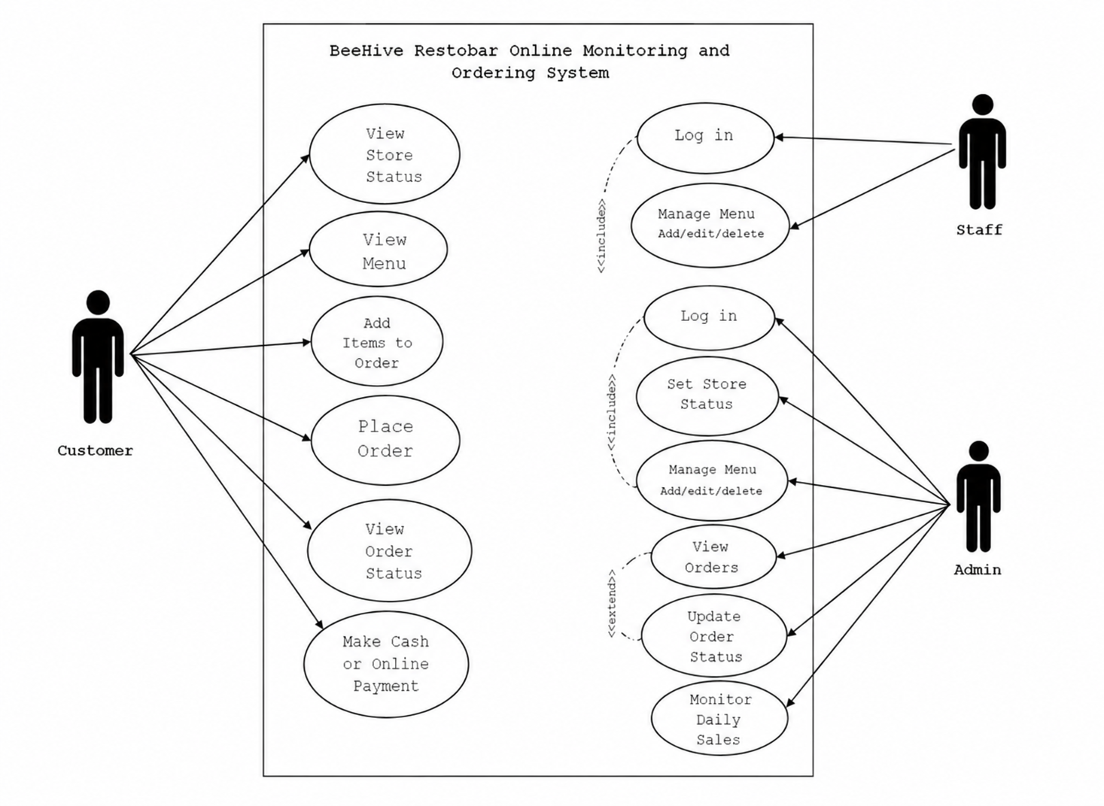
Manage /View/ Update Orders
Monitor
Sales

